**Project Final Report**

**Data Mining COMP 7/8118**

**Ali Riahi Samani (**[**rhsamani@memphis.edu**](mailto:rhsamani@memphis.edu)**)**

**Department of Civil Engineering**

**University of Memphis**

**Fall 2020**

**Does Splitting a long-Automated Driving Trip into Shorter Section Decrease the Rate of Drivers Aggressiveness?**

**Abstract**

Autonomous Commercial Motor Vehicles (CMVs) have the potential to reduce the occurrence of crashes, enhance traffic flow, and reduce the stress of driving to a larger extent. Since fully automated driving is not yet available, SAE Level 5 driving systems can perform all driving tasks under all road conditions, provided drivers need to regain vehicle control when the system reaches its limit, resulting in driver to take-over the control and such transition is referred as take-over condition. This report aims to classify Commercial Motor Vehicle (CMV) drivers’ driving style after this transition and to gain behavioral insights on vehicle control features. To accomplish this objective, we have designed an experiment and assessed the behavior of certified commercial vehicle driver responses to critical tasks performed during take-over conditions. Many factors can influence the driver’s behavior (in a more general way, drivers’ driving style) after a Take-over condition. In this report the effect of long-automated driving condition on driving style is evaluated. Moreover, this report is trying to address this question that if splitting a long-automated driving journey into shorter part can reduce the rate of aggressive style or not? To accomplish this objective, an experiment is design on a driving simulator to collect data from CMV drivers. A Support Vector Machine (SVM) method is applied to classify CMV drivers into two classes, normal and aggressive. Then the rate of aggressive driving style is compared between two scenarios. To have a better classification, a distance-based model is applied to detect outliers.

1. **Introduction**

The idea of a fully automated vehicle is not new anymore, however the implementation of this technology has gained more attention, in recent years. Until automated driving systems can perform all driving tasks under all road conditions (full automation, level 5, based on SAE International definitions (SAE 2014)), drivers will have to take over control when the system reaches its operational limits and sends a Take-Over Request (TOR) to the driver. Drivers’ performance after transition from automated to manual driving is an important question in the autonomous vehicle’s safety studies, specifically, in automation level 3 (conditional automated) and automation level 4 (highly automated). Because drivers in these two levels can engage in non-driving tasks during the automated operation. Previous studies showed drivers’ performance after the transition to manual would be different in comparison with continuous manual driving (Merat and Jamson 2009)(Brandenburg and Skottke 2014) (Varotto et al. 2015) (Stanton and Young 1998) and drivers situation awareness will decrease during and after the transition from automated operation to manual driving (Vogelpohl et al. 2018). Moreover, De (De Winter et al. 2014) showed these changes are more significate in highly automated driving (level 4) compared to conditional automated (level 3).

Assessing drivers’ behavior during and after a take-over request (TOR) is a widely studied area and different aspects of a TOR have been reviewed. In this regard, a group of studies evaluated the effect of different quality of monitoring driving behavior during the autonomous operation. They expressed that the degree to which drivers monitor the automated driving can affect the transition to manual and time require (Vogelpohl et al. 2018). Some studies evaluated the effect of engaging in non-driving related tasks, like playing video game (Melcher et al. 2015), reading (Eriksson, Banks, and Stanton 2017), watching movie (Yoon and Ji 2019) during the autonomous operation and compared the reaction time and driving quality with the condition drivers monitor the automated driving. Moreover, (Naujoks, Mai, and Neukum 2014)(Naujoks, Mai, and Neukum 2014)(Merat et al. 2012)(Gold et al. 2016) showed that the complexity of the condition during the take-over request can directly affect drivers’ situation awareness and leads to a reduction of driving quality.

From another point of view, studies employed different measures to assess the drivers’ behavior and reaction time in a take-over request. Self-reported measure (objective survey) (Heikoop et al. 2018), tracking drivers’ eye-movement (Gold et al. 2013) (Vogelpohl et al. 2018), drivers' physical condition (i.e. hands positions and movement)(Heikoop et al. 2018)(De Winter et al. 2014) are among the approaches researchers applied. In addition to these measures, measuring drivers’ driving quality similar to brake pressure rate, acceleration/deceleration rate, steering wheel movement, the standard deviation of lane position is another approach among researchers (Brandenburg and Skottke 2014)(Merat et al. 2014). Considering all approaches applied to investigate drivers’ reaction to Take-Over Request, assessing drivers’ driving style received less attention.

In literature, most studies reviewed passenger car drivers’ reactions after a Take-Over Request. While a significant proportion of vehicles in the US are Commercial Motor Vehicle (CMV). Moreover, Statics show that the US surface freight transportation would increase by up to 37% by 2045 (Hwang et al. 2016). This ever-increasing rate of freight transportation has attracted more attention to CMVs’ safety. Several companies have investigated in automated CMV technologies such as Otto/Uber, Waymo/Google, Tesla, Volvo, Embark, Daimler / Mercedes. Therefore, it is forecasted that CMVs will be the first to be adopted automated vehicle technology (i.e., Level 4) compared to passenger vehicles as organizational adoptions historically occur first compared to individual adoption. In this regard, as mentioned earlier, until the full automation (level 5 of automation) is not completely implemented, CMVs’ drivers’ behavior during and after take-over request should be considered. Limited studies have been conducted in this area. (Zhang et al. 2019) evaluated trucks drivers’ reaction time during the take-over request considering three different level of autonomous operation monitoring and under platooning scenarios.

* 1. **The aim of this study**

The objective of this research is to investigate the CMVs drivers’ driving style during and after transition from autonomous to manual driving (during and after TOR). In this regard, a simulation experiment is designed on a medium-fidelity driving simulator (RDS-500) and 40 CMV driving license holders asked to take the designed experiment (DUE TO COVID-19 CONDITON WE COULD JUST COMPLETE THE TEST FOR 10 PARTICIPANTS). Drivers’ braking (brake pressure), acceleration/deceleration rate, velocity, headway to the front vehicle, the standard deviation of lane positioning (SDLP), lateral acceleration, and steering wheel angel are recorded constantly during the experiment. As mention earlier, different factors affect the driver’s behavior and performance after a Take-Over Request. In this report the effect of autonomous operation duration on CMV drivers’ driving style. Divers’ style is evaluated in 3 different autonomous operation duration, 10 min, 20 min, and 40 min. Only a few studies have been conducted to assess the effect of automated driving duration on the drivers’ driving performance while the results are varied. In addition, previous studies applied simple statical analysis to assess driver’s behavior while, in this research driving style would be analyzed, using Support Vector Machine (SVM) to classify drivers’ driving style using the data collected from Driving Simulator.

To sum up, the aim of this study is to answer this question “whether or not dividing a long-automated driving into the shorter segment is an approach to improve driving quality and safety in highly automated conditions?”

1. **Method**
   1. **Participants**

So far, 10 participants with a valid commercial driver's license (CDL) with minimum 1 year of commercial driving experience and a minimum of 10,000 mile driving per year, were asked to take part in this study. They were paid $40 for taking the experiment. No more particular criteria were used for recruiting participants. Participants divided into two groups of 20 (Group A and B). Participants were asked to consider a 2-hour experiment in their schedule.

* 1. 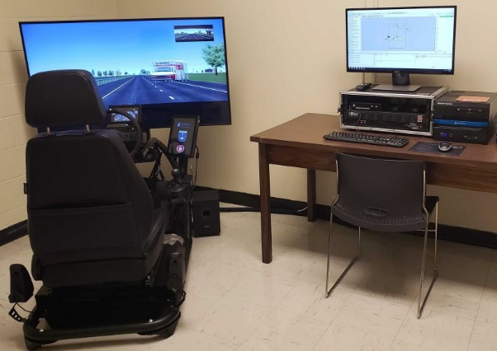**Apparatus**

Figure 1. University of Memphis Driving Simulator

This research is conducted in driving simulator-based experiments, at the University of Memphis Driving Simulator lab, using a medium-fidelity RDS 500, a research driving simulator (developed by Real-time Technologies LLC.), which uses the robust software developed for high-fidelity research simulators. This simulator has an operator station laptop and a high-end simulation computer with one 55-inch HD monitor and a USB-based steering wheel and pedal set along with 5.1 surround sound audio system (Figure 1).

* 1. **Experiment**

An 80-minute experiment is designed in the driving simulator. The environment of the experiment was a separated two-way freeway with 2 lanes in each direction incorporating gentle curves and the speed limit of 70 mph. The starting point was in the entrance of the freeway and the participants had to take out the vehicle from park. The first 10 minutes of driving was designed for training participants. Because participants did not have the experience of driving on a simulator, so they needed enough time to get used to the device. The training section was designed precisely to eliminate the errors that the first experience of driving with a driving simulator may cause. Moreover, during the training section participants experience one take-over request. In the designed experiment, take-overs were requested by an auditory alert and 10 seconds before the system reaches its limits. This time is known as budget time (the time between system limit and when the system should send the takeover request). Researches addressed this time and different studies came up with different adequate budget time in order to have appropriate and safe take-over performance. (Walch et al. 2017) discussed 17 take-over studies, focusing on the effect of the time budget, traffic complexity, non-driving task, and driver age. The authors concluded that 10 s seems an adequate time budget while pointing out that the driver state and situational circumstances affect the driver’s ability to take over control. After the training section, the experiment starts. During the experiment the participants’ driving performance and quality were constantly recorded. The ambient traffic was regular, and the weather condition was sunny. The designed experiment divided into two sections. The first section is devoted to manual driving where participants were responsible for the whole driving tasks (longitude and lateral control) and must drive for 10 minutes. Two critical events (i.e. a crash and a sudden end of a lane) were designed in this section with the time interval of 5 minutes. Participants’ responses to these two critical events are considered as the Baseline Drive. After 10 minutes participants were asked to set on the automated driving. Here the second section starts. The second section contains highly automated driving (HAD). The system is responsible for longitudinal and lateral control of the vehicle.

The automated operation section divided into two scenarios. Each group of participants must take one scenario (Group A took the first scenario and Group B took the second scenario). The first scenario consists of six take-over conditions with a fix time interval of 10 minutes. While the second scenario contains two take-over conditions with different time intervals. The first take-over request is sent after 20 minutes of autonomous driving and the second after 40 minutes. Figure 2 demonstrates the designed experiment’s sections and scenarios. After each take-over, participants had to drive for 1 minute and then turn on the automated driving. Participants’ driving behavior and responses will be classified. It should be mentioned that during the experiment take-over conditions contained critical events. Generally, in this experiment, designed critical events caused a capacity reduction. Two general critical events were defined in this study, a car crash with two cars and a sudden end of a lane due to road construction, stationary vehicle, and obstacles. All the events happened in the lane vehicle were driving on, to force the participants to take action (in both sections, manual and automated driving). Although the feature of the events was different, to avoid participants’ prediction of the condition, the geometry of the event (length, width, and effective area) was the same.

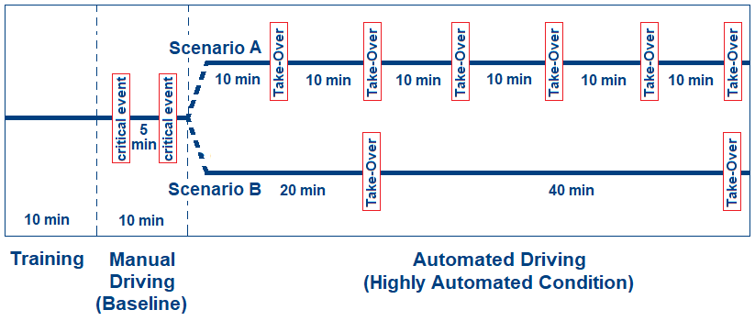

Figure 2. The schematic of the designed experiment

* 1. **Classifying Driving Style**

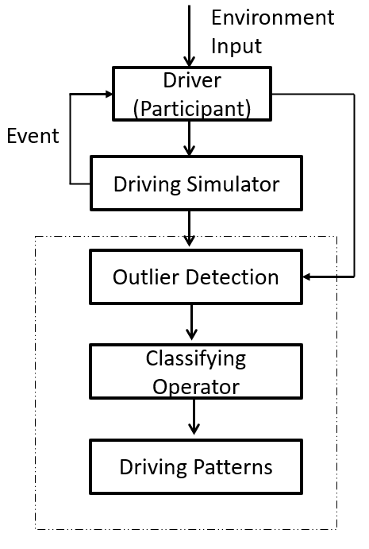In this section, the method applied to predict the driving style after TORS are provided. In the following subsections, the method applied to clear and prepare the data for training is discussed and then classification approach is provided. As mentioned before, the data collected from the manual driving is used to train the machine and defining two driving style. In this report the driver’s behaviors are classified into two classes, normal (N) and aggressive (A). Then the data collected from the Automated Driving section is classified. The structure of proposed recognition method is shown as Figure 3.

Figure 3. The schematic diagram of the proposed pattern recognition method for driving styles.

* + 1. **Detecting outliers**

If you consider the data collected from an individual driver, at each second the statues of vehicle (e.g. velocity, acceleration, etc.) are recorded. If we call this data a record (or a row), for a driver after each TOR we will have 60 records. Since these records should present a driving style, an outlier detection approach is applied to clean and lead the data collected to a single cluster. In this report a simple distance-based outlier detection approach is applied.

* + 1. **Classification**

In this report Support Vector Machines (SVM) is applied to classify the drivers driving style after each TOR. SVM as a tool of solving problems in classification, regression, and novelty detection, becomes popular in recent years and has been widely involved in voice or speaker detection (Hatch, Kajarekar, and Stolcke 2006), image processing (Cusano, Ciocca, and Schettini 2003), human action detection (Schuldt, Laptev, and Caputo 2004), etc. An important property of SVM is that determining the model parameters is equal to solve a convex problem, guaranteeing the global optimum. In this report the MATLAB data mining toolbox is used to apply classification.

The data collected from driving simulator is a high-dimensional data set. Seven data set is constantly recorded. After each TOR, drivers’ behavior collected for one minute and considered as the source of classification. The collected data sets are as follow:

* Braking (brake pressure)
* Acceleration/deceleration rate
* Velocity
* Headway to the front vehicle
* The standard deviation of lane positioning (SDLP)
* Lateral acceleration
* Steering wheel angel

In this project, before applying the classification through SVM, the best features for classification are selected using “sequentialsf” function. This function would select the best classifier among all data set. After selecting best features, the parameters of the best hyperplane are evaluated using “fitcsvm’ function in MATLAB.

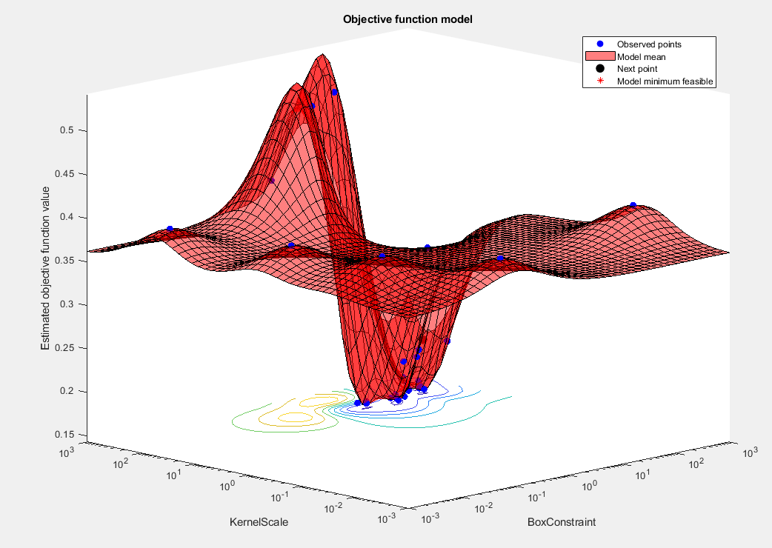

Figure 4. The result of fitting a hyper plane to the training data

**Results**

In this section the result of classifying participants driving style after Take-Over Requests are provided. So far, we could collect the data for 10 participants. We divided them into to groups of five. The first group faced six TORs with the time interval of 10 minutes in the automated driving section and the second group had two TORs during the automated driving section: while the first TOR happened after 20 minutes and the second TOR happened after 40 minutes. The driving style of the first and the second group after each TOR are provided in Tables 1 and 2 respectively. In these two tables “A” represents aggressive driving style and “N” represent the normal driving style.

Table 1. The first group driving style after sequence of six TORs

|  |  |  |  |  |  |  |
| --- | --- | --- | --- | --- | --- | --- |
| Participant | TOR 1 | TOR 2 | TOR 3 | TOR 4 | TOR 5 | TOR 6 |
| #1 | A | N | N | N | A | N |
| #2 | N | N | N | N | N | N |
| #3 | N | N | N | N | N | N |
| #4 | A | N | N | N | N | N |
| #5 | A | A | N | N | A | A |

Table 2. The second group driving style after two TORs

|  |  |  |
| --- | --- | --- |
| Participant | TOR 1 | TOR 2 |
| #6 | A | A |
| #7 | A | A |
| #8 | N | A |
| #9 | A | A |
| #10 | N | N |

Table 1 shows, there is a high chance of showing aggressive behavior after the first TOR. Although five tests can not be strong source of analysis, 60% percent of participants showed aggressive behavior after regaining the vehicle control. Among the first group the rate of aggressive decreased after the first TOR. As Table 1 shows the first group had completely normal behavior during third and fourth TORs. The result of this table shows that drives behavior after a TOR can be improved by teaching drivers how to react and response to a TOR.

Participants behavior in second scenario was quite interesting. Similar or the first group, participants showed 60% aggressive behavior after the first TOR. In the second group the first TOR happened after 20 minutes. Based on this result, participants behavior after the first TOR was similar between both groups. It shows that the effect of facing the first TOR is more than duration of the automated driving. However, participants behavior showed a high probability of showing aggressive driving style after 40 minutes of automated driving. participants in the second group showed 80% aggressive driving behavior after the second TOR. The results become more interesting when we compare the last TOR of both groups with each other. The first group showed 20% aggressive behavior after the last TOR, while 80% of participants in the second group shoed aggressive behavior after the last TOR. It can clearly show that 40 minutes of automated increases the probability of showing aggressive behavior. Also, it can be concluded that after one hour of automated driving drivers who had more TOR during their trip perform a better and normal driving style.

**Conclusion**

In this report the effect of long-automated driving on CMV drivers’ driving style after TORs is investigated. The aim of this report was to answer this question “whether or not dividing a long-automated driving into the shorter segment is an approach to improve driving quality and safety in highly automated conditions?”. An experiment designed on a driving simulator to collect data. The goal was to compare the driving style between two scenarios. Both scenarios had one hour length; while the first scenario divided into six TORs and the second scenario divided into two TORs. A SVM method applied to classify driver’s behavior after each TOR. Results showed that splitting a long-automated driving into shorter segment would help drivers to have a normal driving style. One the other hand, results showed that drivers will show aggressive behavior after their first experience of facing a TOR, irrespective of the duration of automation mode. Moreover, the results showed that drivers’ behavior will improve after sequence of TORs.

**References**

Brandenburg, Stefan, and E-M Skottke. 2014. “Switching from Manual to Automated Driving and Reverse: Are Drivers Behaving More Risky after Highly Automated Driving?” In *17th International IEEE Conference on Intelligent Transportation Systems (ITSC)*, IEEE, 2978–83.

Cusano, Claudio, Gianluigi Ciocca, and Raimondo Schettini. 2003. “Image Annotation Using SVM.” In *Internet Imaging V*, International society for optics and photonics, 330–38.

Eriksson, Alexander, V A Banks, and N A Stanton. 2017. “Transition to Manual: Comparing Simulator with on-Road Control Transitions.” *Accident Analysis & Prevention* 102: 227–34.

Gold, Christian, Daniel Damböck, Lutz Lorenz, and Klaus Bengler. 2013. “‘Take over!’ How Long Does It Take to Get the Driver Back into the Loop?” In *Proceedings of the Human Factors and Ergonomics Society Annual Meeting*, Sage Publications Sage CA: Los Angeles, CA, 1938–42.

Gold, Christian, Moritz Körber, David Lechner, and Klaus Bengler. 2016. “Taking over Control from Highly Automated Vehicles in Complex Traffic Situations: The Role of Traffic Density.” *Human factors* 58(4): 642–52.

Hatch, Andrew O, Sachin Kajarekar, and Andreas Stolcke. 2006. “Within-Class Covariance Normalization for SVM-Based Speaker Recognition.” In *Ninth International Conference on Spoken Language Processing*,.

Heikoop, Daniël D, Joost C F de Winter, Bart van Arem, and Neville A Stanton. 2018. “Effects of Mental Demands on Situation Awareness during Platooning: A Driving Simulator Study.” *Transportation research part F: traffic psychology and behaviour* 58: 193–209.

Hwang, Ho-Ling et al. 2016. *The Freight Analysis Framework Verson 4 (FAF4)-Building the FAF4 Regional Database: Data Sources and Estimation Methodologies*. Oak Ridge National Lab.(ORNL), Oak Ridge, TN (United States).

Melcher, Vivien et al. 2015. “Take-over Requests for Automated Driving.” *Procedia Manufacturing* 3: 2867–73.

Merat, Natasha et al. 2014. “Transition to Manual: Driver Behaviour When Resuming Control from a Highly Automated Vehicle.” *Transportation research part F: traffic psychology and behaviour* 27: 274–82.

Merat, Natasha, and A Hamish Jamson. 2009. “How Do Drivers Behave in a Highly Automated Car?”

Merat, Natasha, A Hamish Jamson, Frank C H Lai, and Oliver Carsten. 2012. “Highly Automated Driving, Secondary Task Performance, and Driver State.” *Human factors* 54(5): 762–71.

Naujoks, Frederik, Christoph Mai, and Alexandra Neukum. 2014. “The Effect of Urgency of Take-over Requests during Highly Automated Driving under Distraction Conditions.” *Advances in Human Aspects of Transportation* 7(Part I): 431.

SAE, J. 2014. “3016: 2014 Taxonomy and Definitions for Terms Related to on-Road Motor Vehicle Automated Driving Systems.” *Society of Automotive Engineers*.

Schuldt, Christian, Ivan Laptev, and Barbara Caputo. 2004. “Recognizing Human Actions: A Local SVM Approach.” In *Proceedings of the 17th International Conference on Pattern Recognition, 2004. ICPR 2004.*, IEEE, 32–36.

Stanton, Neville A, and Mark S Young. 1998. “Vehicle Automation and Driving Performance.” *Ergonomics* 41(7): 1014–28.

Varotto, Silvia F, Raymond G Hoogendoorn, Bart van Arem, and Serge P Hoogendoorn. 2015. “Empirical Longitudinal Driving Behavior in Authority Transitions between Adaptive Cruise Control and Manual Driving.” *Transportation Research Record* 2489(1): 105–14.

Vogelpohl, Tobias et al. 2018. “Transitioning to Manual Driving Requires Additional Time after Automation Deactivation.” *Transportation research part F: traffic psychology and behaviour* 55: 464–82.

Walch, Marcel et al. 2017. “From Car-Driver-Handovers to Cooperative Interfaces: Visions for Driver–Vehicle Interaction in Automated Driving.” In *Automotive User Interfaces*, Springer, 273–94.

De Winter, Joost C F, Riender Happee, Marieke H Martens, and Neville A Stanton. 2014. “Effects of Adaptive Cruise Control and Highly Automated Driving on Workload and Situation Awareness: A Review of the Empirical Evidence.” *Transportation research part F: traffic psychology and behaviour* 27: 196–217.

Yoon, Sol Hee, and Yong Gu Ji. 2019. “Non-Driving-Related Tasks, Workload, and Takeover Performance in Highly Automated Driving Contexts.” *Transportation research part F: traffic psychology and behaviour* 60: 620–31.

Zhang, Bo, Ellen S Wilschut, Dehlia M C Willemsen, and Marieke H Martens. 2019. “Transitions to Manual Control from Highly Automated Driving in Non-Critical Truck Platooning Scenarios.” *Transportation research part F: traffic psychology and behaviour* 64: 84–97.